Come swim in the “Shark Tank” with ChordBuddy, the fastest way to teach guitar is made in Alabama!
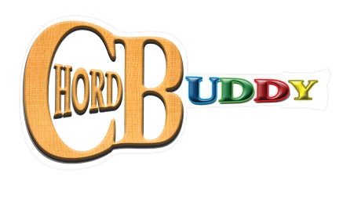
- Where to start?
  - Have a desire to teach guitar!
  - With ChordBuddy you don’t have to know how to play the guitar to teach the guitar
  - Have students who are motivated to learn guitar
  - Develop goals for the journey you are about to take
  - Funding
  - Jump right in! There is no right or wrong way to do this.

- Making the classroom environment fun for the kids:
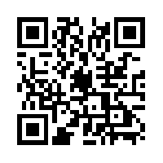
  - Name the Guitars
  - Pick Punch (from Amazon)
  - Digital Tuners & Tuning Stickers
  - Sharing Guitars: peers working together to learn the instrument

- Repertoire/Method Books
- ChordBuddy Teaching Method Vol. I by: Travis Perry & Elena Ryan
- ChordBuddy Junior by: Travis Perry & Elena Ryan
- ChordBuddy Songbook by: Travis Perry
- ChordBuddy Worship Songbook by: Travis Perry
- ChordBuddy Christmas Songbook by: Travis Perry

- Teaching Guitar Can Be Easy?
- Now you can meet the needs of all students and all abilities in your classroom
- Beginning guitar in Kindergarten is possible with the ChordBuddy Junior
- Teachers who don’t play guitar can use the DVD and ChordBuddy to be the model for instruction
- Use guitar journals and our 12-point checklist to assess student growth
- The ChordBuddy:
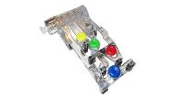
ChordBuddy’s learning system attaches to the neck of the guitar and allows students to play chords instantly by pushing a button. As students progress, the four buttons are removed (like training wheels on a bike) and the student independently plays the chords. The purpose of the ChordBuddy is to first make students into musicians, focusing on the various aspects of playing, before learning how to play chords on the strings. ChordBuddy guitar will quickly become a way for students to express themselves and share music with others.
- How does the ChordBuddy differentiate instruction?
- Bring the focus to right hand skills first: Strumming, steady beat, playing the correct strings for each chord, pick grip, etc.
- Physical Modifications: Play the guitar flat, partner playing, modified pick
- Allows for modifications in speed of the learning: Remove a button when you are ready, use alternate repertoire, etc.

- The ChordBuddy Junior:
- K-4th Grade
- The CB junior guitar has wings on the nut to attach the ChordBuddy
- Songbook is color-coded and the DVD walks you through the strum patterns and songs
- Digital Tuner makes tuning easy
- Tuning peg stickers allow older students to learn how to tune with ease

- The ChordBuddy (Right, Left, and Classical Guitar Sizes Available):
- 5th grade-Adult, the buttons come off
- Fits any full-size acoustic or electric guitar
- Fits some youth size guitars (fits all Perry youth size guitars)
- Buttons are removable and come off when the student is ready

- Title I Funding for ChordBuddy
- Under the Every Student Succeeds Act music education is a part of the well-rounded education for children. This means that Title I funding can be used for music. See the attached document for the language you need to explain the benefits of ChordBuddy in your school.
- iPad Compositions:
- Educreations app: allows for composition and recording
- Students can color-code the music
- Students record themselves playing their composition
- Easy to email to teachers for feedback

- Garageband Accompaniments:
- Create an accompaniment track to a song or warm-up
- Compose your own G-major composition
- Visit our website for instructional videos that can show you how to use Garageband

- iPad Playing Log:
- Make entries often, consider using a google form to collect data
- Keep the log in the camera roll, google drive, schoology, etc.
- Write a 0-4 Journal entry based on your playing logs
- Share video journals with parents!

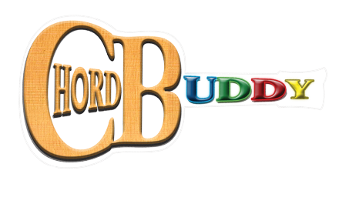

Need help writing a grant?
Here is the language you need to bring ChordBuddy into your school!

With the use of the ChordBuddy guitar system, every middle school student will learn how to play songs on the guitar. This device makes playing the guitar quick, easy, and accessible for all learners. It is a differentiated device that simplifies guitar playing for students without prior guitar experience while providing additional challenges for experienced learners.

The ChordBuddy is a plastic attachment that goes onto the fret board of the guitar and rests above the strings. Each colored tab represents a different chord - similar to the popular “Guitar Hero” video game children play on PlayStation and Xbox, only it removes them from the TV and has them playing the actual guitar. The 4 chords you can play are C major, D major, G major, & E minor. The system comes with a DVD, Teacher Book, Student Books, and various supplemental songbooks. The player slowly removes the colored tabs from the plastic device and eventually plays without the assistance of the device. The implementation of guitar into the general music curriculum would be a permanent change and will be offered to every student that comes through the Schools from 2016-forever.

Being a high-caliber music teacher means teaching the curriculum to students in a variety of ways while engaging them fully in the learning process. It also means that we remain up-to-date and innovative with the latest technologies available in music education. The teachers will use ChordBuddy prior to working with the kids to enhance their own knowledge and ability level on the guitar. Once the grant is approved and the guitars reach the schools, teachers can meet and collaborate on lesson plans and assessments. During collaboration time teachers will continue to share knowledge, tools, and successes of the ChordBuddy system and refine the teaching of guitar in our schools.

The general music classrooms would also experience a wonderful change in the classroom environment, as the guitars will hang on the walls when they are not being played. Wall hangers will be installed in the rooms and the guitars will spend the school year hung up on the walls, and the summer in the black bags that come with the guitars. When one walks into a room that has 17 guitars hanging on a wall, you know something magical is going to happen and that music is actively being made. That is the room our students deserve to learn in, and this is the environment the ChordBuddy grant can provide.

It is without hesitation that we can say this device will engage our students in the learning process. Guitar is one of the instruments that every child wishes they could play, and now we can give that experience to them. Our students can be included in the 50 million people worldwide who play the guitar.

The ChordBuddy was invented to eliminate the initial frustrations that kids feel when they start to learn the guitar. The first 3 lessons are usually focused on learning to hold down the strings tight enough, know what frets to hold down to play chords, and learning how many strings to strum to play a song. These steps are all achieved with 100% accuracy when the ChordBuddy system is used, and that is why it will increase learning engagement, academic performance, and give every student we teach the feeling of “Yes, I can do it! I can play the guitar!” As long as you know the colors blue, green, yellow, and red, you can play this guitar using this system. Giving children of all ability levels the same chance for success on the guitar will only be achieved if we use the ChordBuddy.

We know that our students will remain life-long learners of music after they leave our classrooms. We know that they will listen to music for the rest of their lives and guitar will always be a part of that. This learning experience will require students to manage their own practice time, keep accurate practice logs, perform in front of an audience, play with an ensemble, and other skills that transfer into multiple areas of academic and non-academic life. Howard Gardner’s theory of multiple intelligences has a level of musical intelligence and interpersonal intelligence, working with others; we see both of these at work when playing the guitar in the general music classroom. Gardner also recognizes that a variety of decisions must be made when choosing media that is appropriate to a learning style. Sound, color, and performance are all detailed as media that can impact learning; this program reaches all 3 of these areas.

There are many studies that demonstrate the positive relationship of children’s intelligence and learning an instrument. It is our wish that every middle school child could be in band, choir, or orchestra, but that is not able to happen at this time. Our responsibility in general music, then, is to advance student learning in music and give them experiences that a band, choir, or orchestra student has by virtue of being a member of an ensemble and learning an instrument. Once they see how attainable being a guitar player is with the ChordBuddy system, we will open the music inside of each child and they can use the guitar as a way to share their inner musician!

